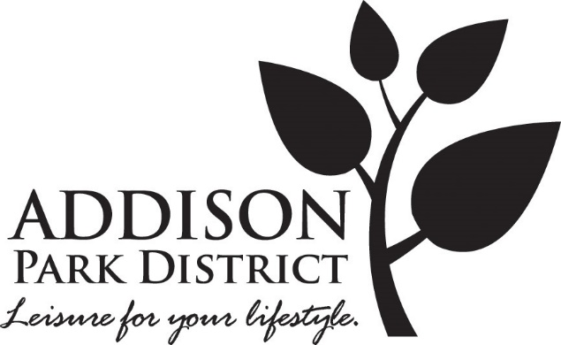

Addison Park District, Addison, IL
Job Description

Job Title: Marketing Assistant
Department: Marketing & Communications

Job Summary
Under the direction and supervision of the Manager of Marketing and Communications, the Marketing Assistant is responsible for providing support for all marketing and communications content for the Addison Park District, which includes, but is not limited to designing and creating marketing communications collateral for print and online use, promotion of the recreation programs, special events, Club Fitness and Links & Tees Golf facilities on social media channels such as Face book, email, Instagram and others. The position requires effective marketing communications writing skills, that when combined with high quality graphic designs, encourages readers to have a positive impression and act accordingly to the objectives of the program.

Qualifications:
- Associate degree required, four-year degree preferred in graphic design, marketing, communications, and/or related field.
- Preference given to candidates with marketing experience and graphic capabilities demonstrated through verifiable portfolio and references.
- Employee must be reliable, show initiative, productivity, resourcefulness, creativity, and problem-solving skills.
- Must possess a strong background and working knowledge of Microsoft Office, Canva, Spark, Indesign, Illustrator, Photo Shop, Word Press, Hootsuite, Constant Contact software applications.
- Preference given to candidates with strong design skills for print and electronic production; good written communication skills including spelling and grammar; strong command of English language; strong organizational skills; ability to manage multi-priorities; strong project management skills; adapt to changing priorities; ability to interact with all levels of staff; ability to work effectively with minimal supervision.

Essential Duties & Responsibilities:
- Employee is responsible for producing, distributing, and evaluating print and electronic marketing communications materials; including but not limited to: quarterly program brochure, print and electronic newsletters, bulletin board displays, advertisements, flyers, pamphlets, posters, and other point of sale collateral.
- Employee must create compelling digital marketing copy to help promote, drive awareness and participation in the Park District’s programs and events. Channels include Facebook, Twitter, Instagram, email blasts, etc.
- Employee will have responsibility for weekly planning of online communications using social media management tools.
- Employee will have responsibility for creating most of the graphics for the Seasonal Brochure Guide. The content and other specifications are in collaboration with the Recreation and Marketing leadership team.
- Employee must create and publish the Active Adults Highlights newsletter six times per year in collaboration with the Active Adults Coordinator. Product is printed and in digital form.
- Employee must maintain print clipping files, photographs, targeted mailing lists, and all other appropriates marketing materials; and develop, catalog and maintain an up-to-date photo and video library for District use, and maintains files and library of all materials produced and resource materials and provide upon request.
- Employee will have responsibility for keeping the District web updated formerly on a quarterly basis and as needed for other updates.
- Employee must track marketing results for reporting in the Monthly Report. Employee will work with the Manager of Marketing and Communications to create a marketing dashboard.
- Employee will assist the Manager of Marketing and Communications to develop standard templates to assist in organizational efficiency of routine operational oriented collateral pieces.
- Employee must maintain and promote excellent customer service relations with patrons, co-workers, and affiliates.

Secondary Duties & Responsibilities:
- Employee must also, as needed, act as the District photographer for special events and key community relations activities and using the pictures along with graphs to further promote the Park District’s objectives and goals.
- Employee must upload the Season Brochure to the Addison Park District web site via WordPress.
- Employee will have responsibility for keeping the Constant Contact email lists updated and segmented by user groups/target markets.
- Employee must write and post special event communications for the District’s and Village marquees.
- Employee must write and routinely upload content on the in-house digital TV system.
- Employee must create and publish the District’s digital school district newsletter.
- Employee will write special advertisements from time to time.
- Employee will assist with the display in Administrative Center's lobby display case.
- Employee will assist with maintaining the required departmental records.
- Employee may communicate with local businesses to coordinate promotions for special events.
- Employee may create photos and copy for the portable display boards, as needed.
- Employee will assist with copywriting for marketing materials and web pages.
- Employee may assist in the management of the marketing communication budget by providing input, forecasting expenses, controlling costs, and periodic pricing analysis.
- Employee may be responsible for maintaining and updating the media list, collect and archive media clips and marketing communications materials.
- Employee must maintain a working knowledge of all general and department safety rules. Enforce safety rules and improve public and employee knowledge by preventing, confronting, and correcting unsafe behavior.
- Employee must follow, administer, and implement park district policies, procedures, guidelines, and crises management plans.
- Employee must perform other related duties and/or special projects as assigned.

Cognitive Considerations:
- Employee must be able to communicate effectively and professionally with the public and staff.
- Employee must be able to follow directions and communicate in both verbally and in writing.
- Employee must develop and maintain knowledge of District programs to create effective promotional materials.

Psychological Considerations:
- Employee must be able to work independently in day-to-day operations with general direction of the.
- Employee must be able to work in a team atmosphere, while promoting the Park District’s mission statement, vision, and core values.
- Employee must have the ability to recognize priorities and meet deadlines.
- Employee must have the ability to receive constructive criticism and/or supervision.
- Employee must have the ability to be flexible and adaptable to new situations.
- Employee must possess enthusiasm and drive with a desire to accomplish goals and objectives.

Environmental & Physical Demands:
- Employee may be required to work both inside and outside during various environmental conditions, such as, but not limited to rain and mud, hot and cold temperatures, exposure to dust, dirt, and noise.
- Employee must operate and handle assigned equipment.
- Employee must have the physical agility to maintain mobility from site to site and be able to perform moderate manual tasks.
- Employee may perform duties which include, but are not limited to prolonged lifting, standing, stooping, bending, twisting, and climbing for extended periods of time.
Date 9.1.2019 – final

Jean Stone
jstone@addisonparks.org

