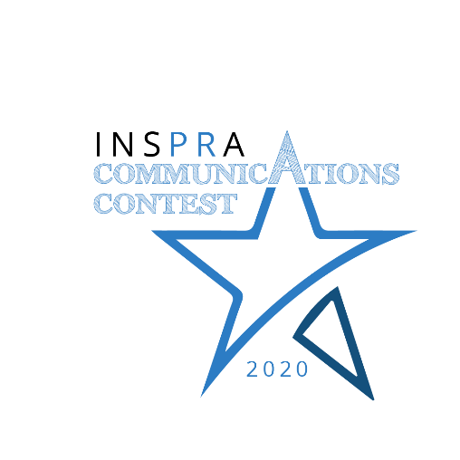
CONTACT:
Kristine Liptrot, APR
INSPRA Past President
kliptrot@y115.org

September 11, 2020

COMMUNICATIONS PROFESSIONALS RECOGNIZED FOR EXCELLENCE
{Local District} was recognized for its exceptional communications efforts by the state’s school public relations association.
The Illinois Chapter of the National School Public Relations Association (INSPRA) held its annual Communications Contest Awards on September 11, at which it recognized the top communications in the state. Professional school communicators from across the country judged the 133 submissions. Each entry was evaluated by three judges against a rubric of excellence, with awards given to those who scored within the established ranges for merit and excellence.
[Awardees’ name(s) and School District name] received an award of [excellence/merit] in the category of [enter category here].
“The entries in this year's communication contest not only showcase the ability of our members to thoughtfully and accurately communicate with constituents on a regular basis, but also shined a spotlight on the importance of having professionals in these positions to manage communication during a crisis such as the one we have experienced during the COVID-19 pandemic,” said INSPRA President Carol Smith, Director of Communications and Community Relations for St. Charles CUSD 303.
The complete list of 2020 INSPRA Communications Contest winners can be viewed at www.inspra.org.

